Teleportation to Venezuela for Prayer
July 22, 2026
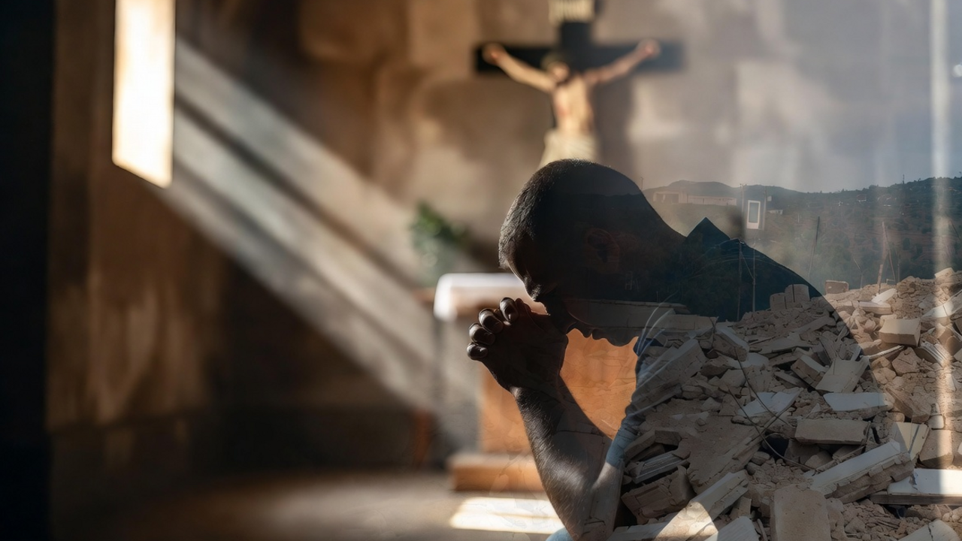
May the Lord increase our love and concern for those who are deeply in trouble in Venezuela and around the world.
My dear ones, in the previous video I explained to you how important it was for us to pray for these souls that are in these desperate situations. And just to give you a heads up on what I want to make this very, very simple.
We were praying—Father Ezekiel and I were praying the rosary, and we were concentrating on Venezuela—and during the rosary we found ourselves in Venezuela. Father was ministering to souls there and I was just walking around. I hadn’t seen anything at that time other than the rubble. But I had a great sense of urgency and compassion for the people that were caught in this horrible event. So, I just prayed for them. And I think if I had persevered and stayed there longer, I would have encountered souls that I could minister to.
Now, I have done this before several times, but it was with Jesus. I was not on my own at the time. And this time I was with Ezekiel. This is open to you. This is a possibility, especially if you consecrate yourself to Padre Pio or ask him to assist you, because he did this all the time. He would be wherever people needed him, giving them last rites, communion—all kinds of extraordinary ways the Holy Spirit used him by moving him from place to place. And this gift can be yours.
There’s only one thing that it requires—well, maybe two things. One is total commitment to love and feel for these people who are in this desperate situation, to give the Lord enough time to help you adjust to this kind of prayer, and for the Lord to come and put you in these circumstances so that you can pray for them. And then a humble heart, knowing that you’ve done nothing. God has done the doing. You were just available to love on the people and pray for them and perhaps administer the sacraments.
This can be done, and if you are sincere, you will not be led into deception. You will actually be doing this wonderful gift for these people. The secret is also humility and knowing again that this was done by God, not by you. You just happen to have the right disposition of heart to reach out to these people.
So, I pray that you will make yourself available to the Lord in prayer. Get very, very still and quiet and pray for those in Venezuela any way you want to pray for them, in the spirit or out loud, however you want to pray for them. Just let the compassion flow out from your heart, and God will do all the rest.
God bless you.

